PRICES :  Full price : 15 €,  Reduced : 12 € (members, unemployed, students, groups 10 or more)  3 or 4 different concerts/person : reduced price applied : 12 €/concert  Children under 12 years (maximum 2 / adult) : free entrance  Pass Festival Day : 27 €  1 concert on 21, 22 or 24 July 2010 + 1 entry at the base de loisirs de la Germanette, + 1 lunch or diner in one of the restaurants partners of Serres Jazz L'Estaminet, le Serrois, le Commerce, l'Hôtel du Nord, le Pont La Barque, La Germanette  In case of bad weather, the concerts to be held at the Théâtre de Verdure would take place at the Salle des Fêtes of Serres. Free parking close to the different venues, all venues accessible to handicapped.  INFORMATION AND BOOKING :  www.festivaldejazzdeserres.com  Serres Tourist Office 04 92 67 00 67  Harmonia Mundi, Gap 04 92 51 59 86  FNAC  And on the venue, one hour before the concerts  Pass Festival day on sale at the Tourist Office  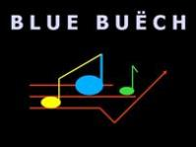  ORGANISATION : ASSOCIATION BLUE BUËCH  Direction Gilles Lambert  Communication Michèle Garagnon  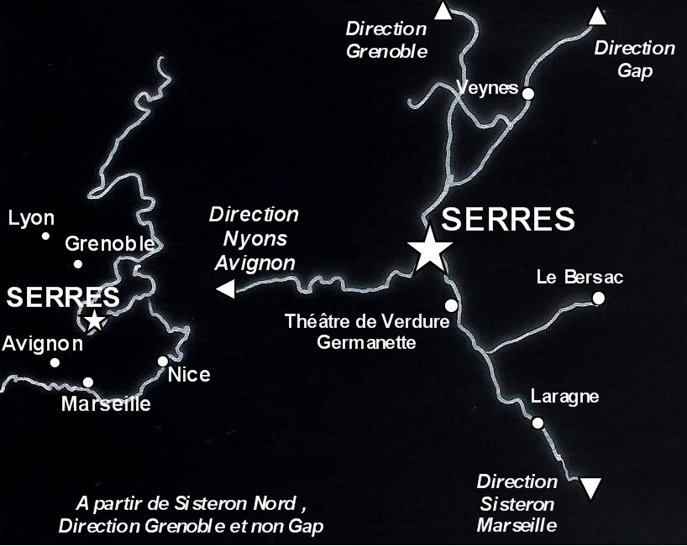 |  |  | 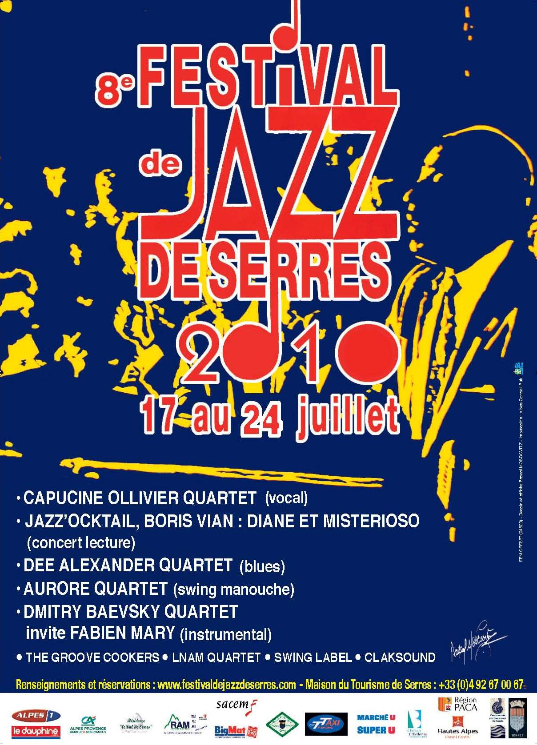  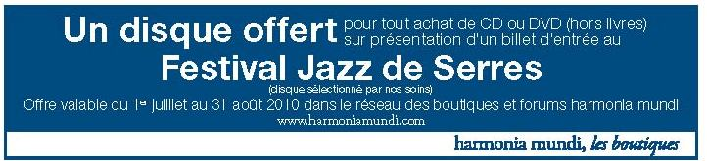
Standards - vocals  Sunday 18 at 21h00  Le Bersac  15 €, reduced : 12 €  Capucine Ollivier, guitar, vocals  Jean Bernard Oury, trumpet  Sébastien Lalisse, piano  Stéphane Massé, double bass  Capucine's voice is caressing, sensual, "naïve" but not silly, melodious and "classy". Her jazz is inspired by the standards, the voices of Chet Baker (the sunny side of Chet), Billy Holliday, Abbey Lincoln, San Fetz sound... The Quartet is composed of talented musicians who will communicate their pleasure to play together  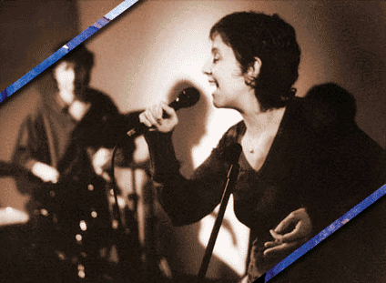 | Concert & Literature  Tuesday 20 at 19h00  Salle des Fêtes de Serres  Free entrance  Diane de Montlivaut, lecture  Nicolas Dejean, sax ténor, flute  Sébastien Lalisse, piano  Emilie Bourgeois, double bass  Alain Antoni, drums  « JAZZ’O'CKTAIL » Boris Vian  Selection of texts by Boris Vian, songs, music, freedom, humour, imagination and dream, a glittering cocktail about Jazz and litterature.  Partnership Bibliothèque Départementale Hautes-Alpes.  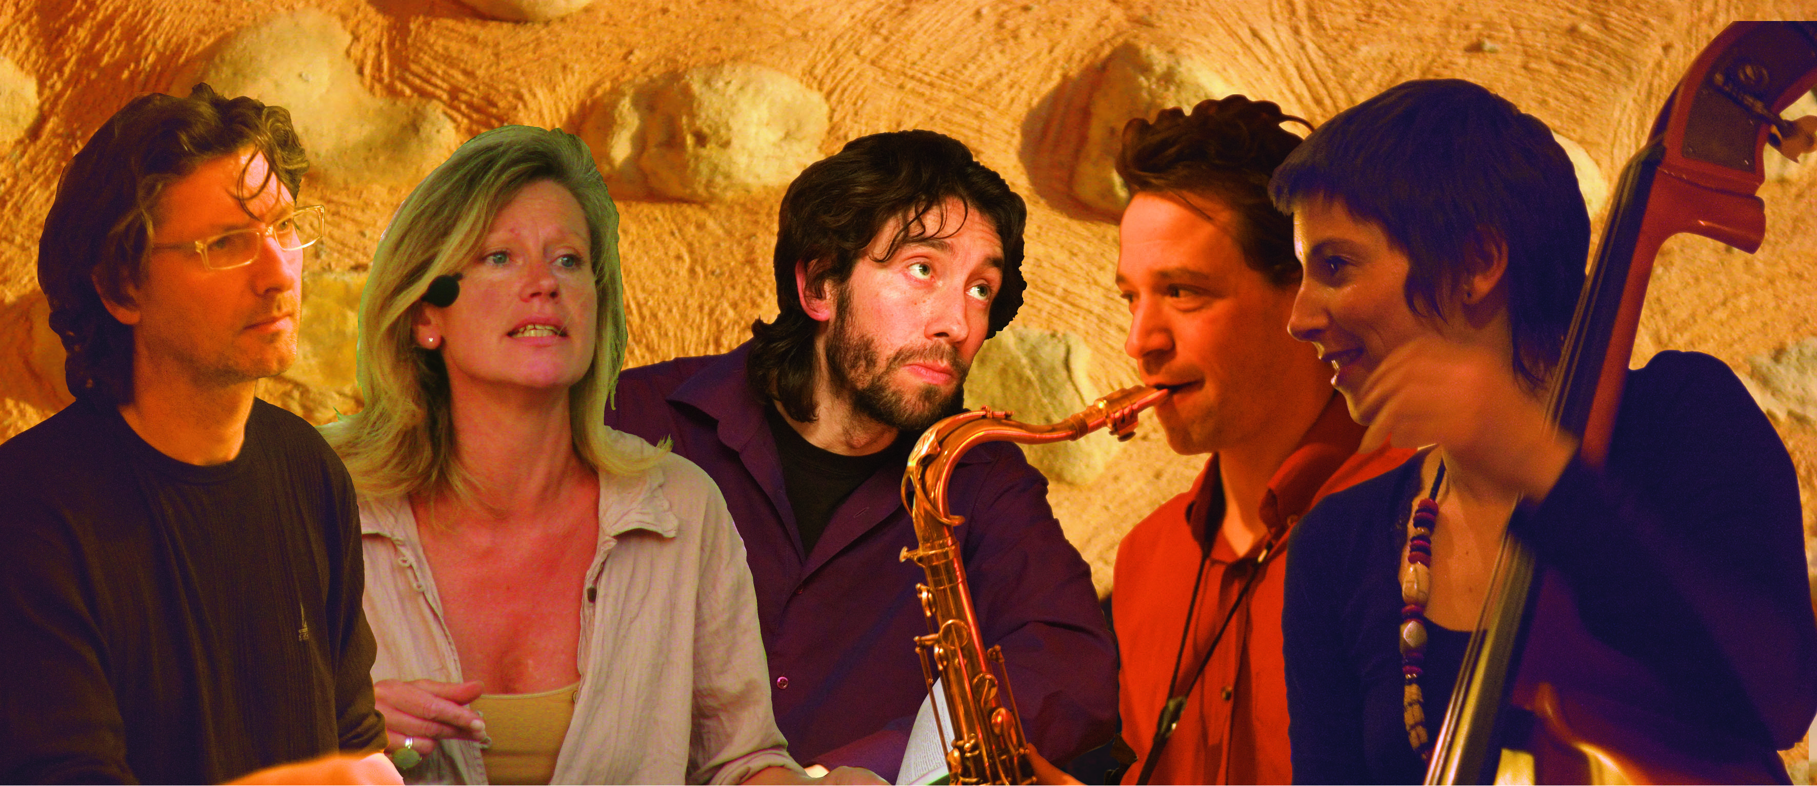 | Blues  Wednesday 21 at 21h00  Théâtre de Verdure  15 €, reduced 12€  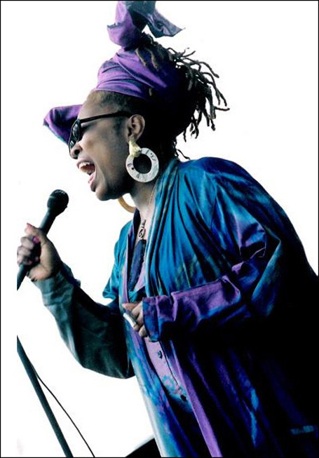  Dee Alexander, vocals,  Miguel Delacerna, piano,  Harrison Bankhead, double bass  Ernie Adams, drums  Dee Alexander is one of Chicago’s most gifted and respected female vocalist/songwriters. Her talents spans every music genre, from Gospel to R&B, from Blues to Neo-Soul. Yet her true heart and soul are experienced in their purest form through her performance of Jazz music. From a soft, sultry traditional ballad, to a contemporary Jazz-Funk groove; from a high flying swing, to a scat-filled romp, Dee Alexander delivers each style with a passion and love of music that comes across in each and every note, and with a style and grace that is truly her own. The last CD Wild is the Wind has encountered a great success. Dee Alexander will start her European tour in Serres. |  | Manouche Jazz  Thursday 22 at 21h00  Théâtre de Verdure  15 €, reduced 12 €  Aurore Voilqué, violin  Patricia Lebeugle, bass  Thomas Ohresser, guitar,  Siegfried Mandacé, guitar,  Take a double bass, two guitars and a violin. Shake, sprinkle with Slavic rythms, gypsy jazz and tunes from yiddish folksongs. Don't forget to add a pinch of swing. And there you have it, the Aurore Quartet. A giddy cocktail : joyful compositions which wake up gypsy jazz. Well served with the cheeky young voice of Aurore Voilque, well qualified in the classical music, before becoming an adept of Django Reinhart and Grappelli, Aurore Quartet, a group to discover urgently in Serres !  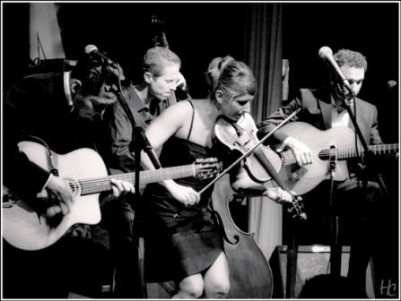 | Jazz instrumental  Saturday 24 at 21h00  Théâtre de Verdure  15 €, reduced 12 €  Dmitry Baevsky - sax alto  Fabien Mary - trumpet  Yves Brouqui - guitar  Mathias Allamane - double bass  Philippe Soirat – drums  «Czar of sax alto », Dmitry Baevsky, born in Russia has become a phenomenom of NYC Jazz. His tasteful, swinging and virtuosic playing has commanded the respect of the most established musicians in New York. He will be joined by the talented trumpetist Fabien MARY. An exceptional event in Serres.  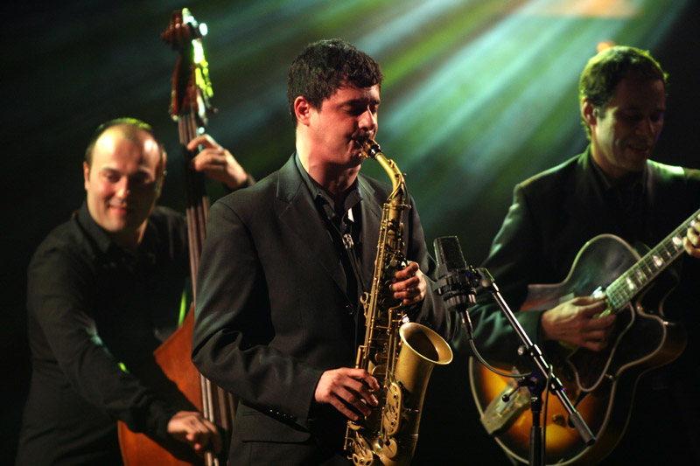
  Capucine OLLIVIER
  DIANE & MISTERIOSO
  Dee ALEXANDER
  AURORE Quartet
  Dmitry BAEVSKY
  invites Fabien Mary
EXHIBITION, BOULES TROPHY, PUBLIC CONCERTS (free entrance)...
FESTIVAL BOULES TROPHY : Boulesl contest 23 July 2010 at 14h00 Place du Lac in Serres Partnership with the association Pignolette Pétanque Club
from 12 till 24 July 2010 : exhibition BOULES AND JAZZ, drawings by Pierre BALLOUHEY at Serres Tourist Office
The GROOVE COOKERS  Saturday 17 at 18h30  La Germanette - Serres  Christian Doncarli, organ  Pierre Payet, tenor saxophone  Franck Rouget, guitar, synthetizer.  Zouz Adelli, drums  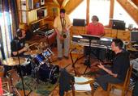  This Quartet plays the Jazz-Rock of the 70'ss, with the soft sounds of the Hammond organ and the tenor saxophone are mixed with funky rythms of guitar and drums for a "well cooked" groove. | LNAM Quartet  Monday 19 at 17h00  Place du Lac Serres  Loïc Marin-Souza, Fender Rhodes  Nicolas Reboud, drums  Arnaud Josset, guitar,  Maud Fourmanoir, Flute  Fender Rhodes, percussions, guitare, flute : a new and creative kind of Jazz mucic, lead by imagination, freedom : that is spirit of Jazz | 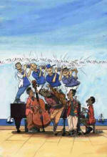 | SWING LABEL  Monday 19 at 18h30  Cafet'U de Veynes  Dominique de la Boissière, vocals  Bernard Galland, tenor sax  Marc Paulin, piano  Phil Casel, double bass  Roland Muret, drums  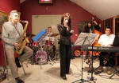  The great and unforgettable standards of Jazz, swing and bossa nova, in a cabaret style. | CLAKSOUND  Friday 23 at 16 h00 and 18h30  Val de Serres and Place de la Fontaine Serres  Esther Mainieri, vocals  Salvatore Virgone, saxophone  Benoît Baruteau, guitar  Julien Vignon, double bass  Rémi d'Aversa, percussions  Multiples influences : funk, jazz, rock, groove, with a some trip-hop ambiance and a slight touch of electronic sound.  

